**Figure B1. Nested cross-validated results for predicted (expected) and observed age adjusted premature NCD mortality (AAPNM) in the municipalities of the state of São Paulo between the years 2010 and 2019. General model without Boruta feature selection.**

**Figure B2. Nested cross-validated results for predicted (expected) and observed age adjusted premature NCD mortality (AAPNM) in the municipalities of the state of São Paulo between the years 2010 and 2019. General model with Boruta feature selection.**

**Figure B3. Nested cross-validated results for predicted (expected) and observed age adjusted premature NCD mortality (AAPNM) in the municipalities of the state of São Paulo between the years 2010 and 2019. Population-filtered for 20,000 inhabitants and over without (a) and with Boruta feature selection (b).**

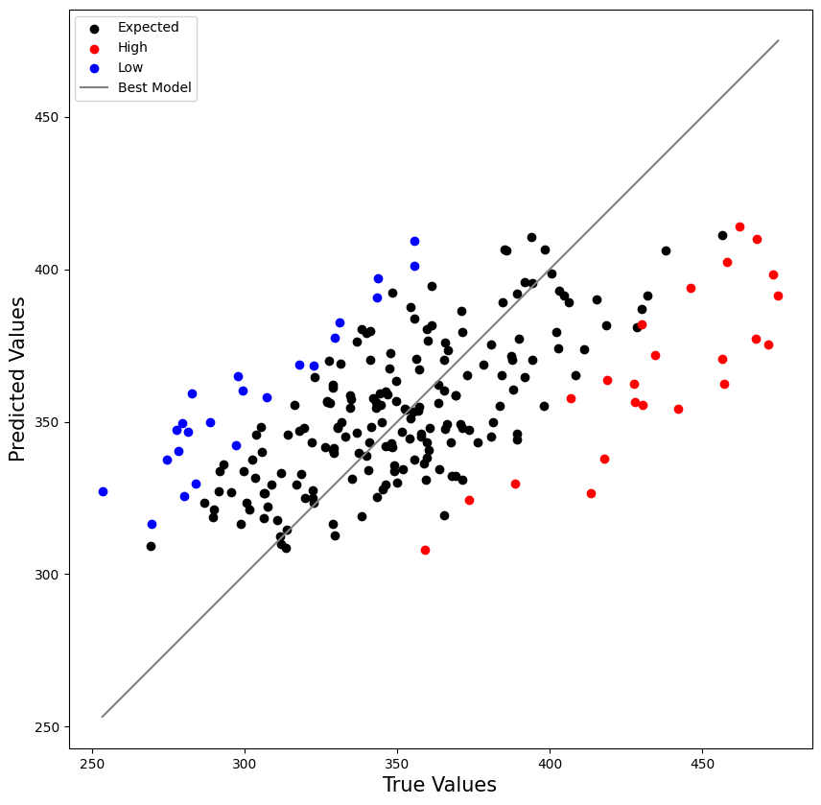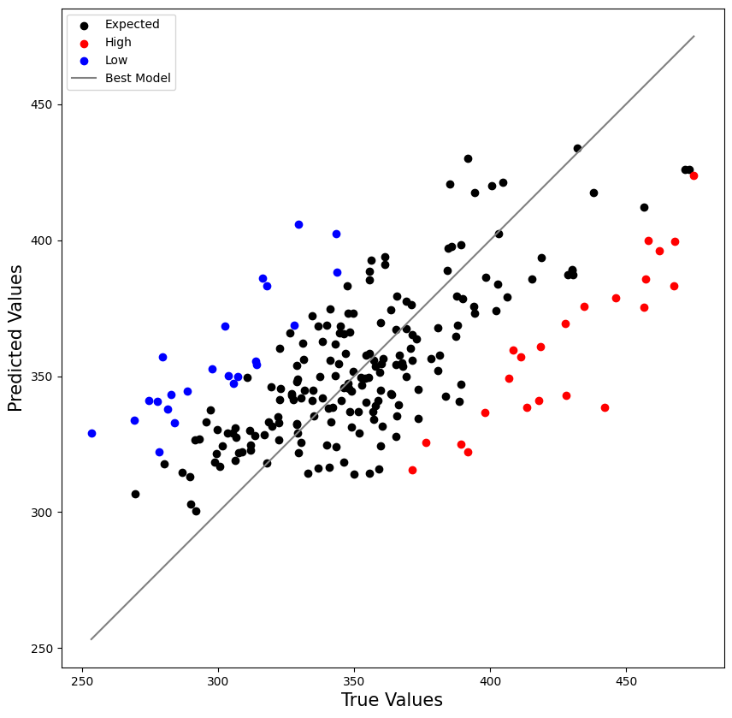

**a**

**b**

**Figure B4. Shapley values summary plot for the catboost model filtered by the municipalities without populational filtering and with Boruta feature selection.**

**Figure B5. Shapley values summary plot for the extra tree model filtered by the municipalities with 20,000 inhabitants and over with Boruta feature selection.**

**Figure B6. Correlation plot for observed and predicted AAPNM and primary health indicators.**

**Figure B7. Correlation plot for observed and predicted AAPNM and primary health indicators for the municipalities classified as ‘High’.**

**Figure B8. Correlation plot for observed and predicted AAPNM and primary health indicators for the municipalities classified as ‘Low.**